Can you name a bird for each letter of the alphabet?
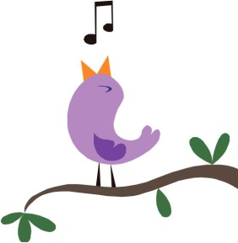
A ....................................... Q..................................
B ....................................... R .................................
C ...................................... S .................................
D ...................................... T .................................
E ...................................... U ................................
F ...................................... V ................................
G ..................................... W...............................
H .................................... X ................................
I ..................................... Y ................................
J ..................................... Z .................................
K ....................................
L ....................................
M ..................................
N ...................................
O ...................................
P ...................................

